Experiment.: 17
HIGH LEVEL PROGRAMMING EXTENSIONS – FUNCTIONS

AIM
To implement Functions using MySQL.
DESCRIPTION
FUNCTION
A function is a stored program that accepts input parameters, performs calculations or operations, and returns a single value.
• Functions improve code reusability.
• They always return one value using the RETURN statement.
• User-defined functions (UDFs) are created using the CREATE FUNCTION statement.
SYNTAX
CREATE FUNCTION function_name(parameters)
RETURNS datatype
BEGIN
statements;
RETURN value;
END;

PROGRAMS AND OUTPUTS
Program – 1
Create a function to return the adoption category based on Adoption Fee.
DELIMITER //
CREATE FUNCTION GetAdoptionCategory(fee DECIMAL(8,2))
RETURNS VARCHAR(20)
DETERMINISTIC
BEGIN
DECLARE category VARCHAR(20);
IF fee > 5000 THEN
SET category='Premium';
ELSEIF fee >=3000 THEN
SET category='Standard';
ELSE
SET category='Economy';
END IF;
RETURN category;
END//
DELIMITER ;
-- Execute the function
SELECT Pet_Name,
Adoption_Fee,
GetAdoptionCategory(Adoption_Fee) AS Category
FROM Pet_Adoption;

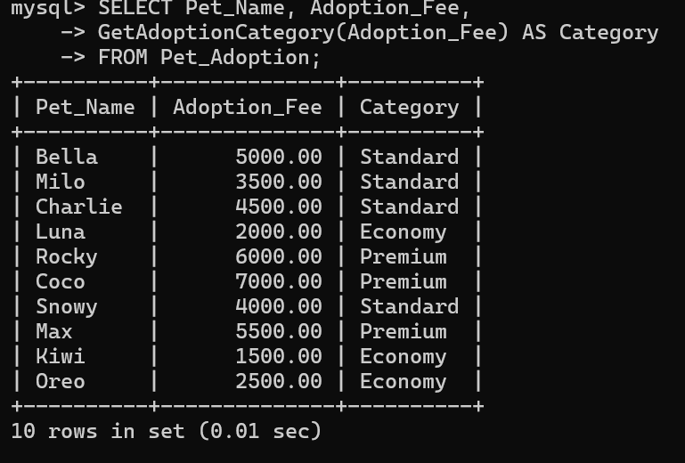

Program – 2
Create a recursive function to find the factorial of a number.
SET @@GLOBAL.max_sp_recursion_depth = 255;
SET @@SESSION.max_sp_recursion_depth = 255;
DELIMITER //
CREATE FUNCTION Factorial(n INT)
RETURNS INT
DETERMINISTIC
BEGIN
IF n<=1 THEN
RETURN 1;
ELSE
RETURN n*Factorial(n-1);
END IF;
END//
DELIMITER ;
-- Execute the function
SELECT Factorial(5) AS Factorial_Value;

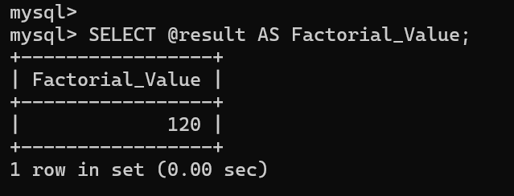
RESULT
Thus, the Functions using MySQL were created and executed successfully.

